Roman Pfanner

5/6/2022

**Latch Circuit**

The purpose of this latch circuit is to create a simple circuit with a latching mechanism that can be used to close a latch for a door or chute. The circuit includes an LED to indicate whether the latch is closed or open. A simple momentary button will be used to turn the circuit on and off, opening and closing the latch or door.

**Materials Needed**

* Raspberry Pi
* Breadboard
* Jumper wires
* 330 ohm resistor
* Small servo motor
* Momentary push button
* LED of any color

**Circuit Design**

Start with creating a simple button circuit as shown below. Attach one jumper wire to GPIO pin #5 and one jumper wire to a Ground pin on the Raspberry Pi. Plug the GPIO #5 wire into the breadboard so it connects with one leg of the button and the ground wire into the breadboard grounding plane. Plug another jumper wire from the ground plane to the other leg of the button

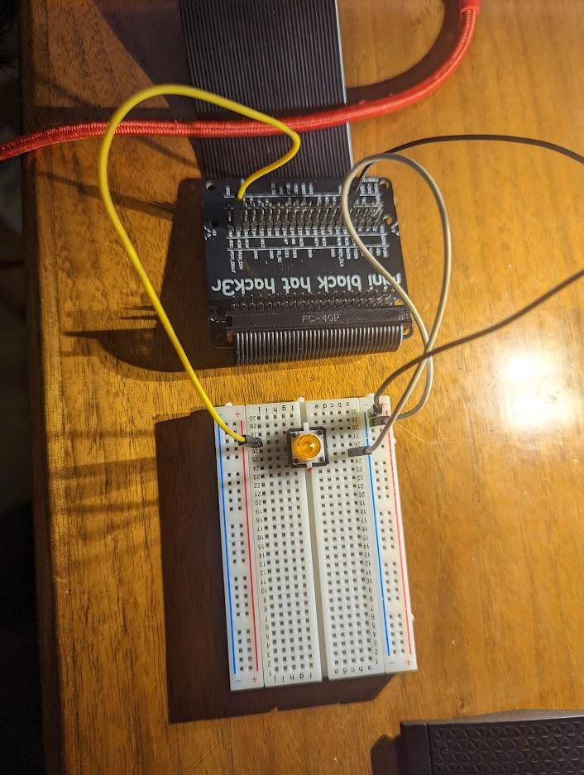

Next we will add the LED to the circuit. Plug the LED into the breadboard. Plug the 330 ohm resistor into the breadboard with one leg of the resistor connecting to the LED. Add a jumper wire from the ground plane to the short leg side of the LED in the breadboard. Connect a jumper wire from GPIO pin #6 to the other leg of the resistor.

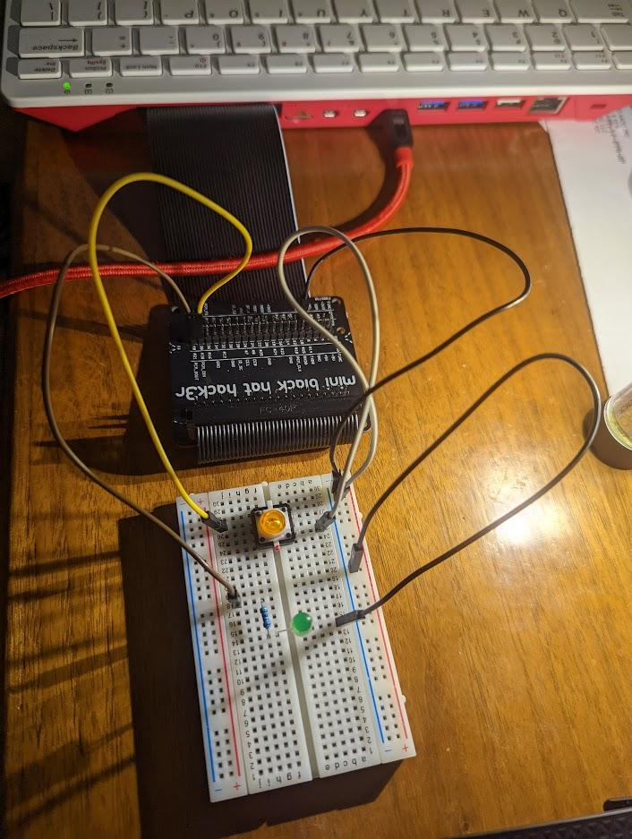

Finally lets add the Servo. Take a jumper wire and connect one end to a 5V pin on the Raspberry Pi. Connect the other end to the center red connection of the servo. Connect another jumper wire from the ground plane on the breadboard to the brown or black connection of the servo. Connect one more jumper wire from GPIO pin #18 to the white or orange connection on the servo.

